

Eigenvectors for Face recognition

Reproducing Results



January 21, 2021

Omar Farooq

Omarfarooq101@gmail.com

# Introduction

This experiment aimed to reproduce results from the paper ‘Eigenfaces for Recognition’ by Matthew Turk and Alex Pentland. The paper introduced the concept of eigenfaces, which was later to become that basis for facial recognition technology. It provides a computationally efficient method of principal component analysis on image data. The first part of this report showcases results from the method in the paper, performed on a dataset of images having resolution 1280x960 of four individuals. Image recognition was done here as well. The second part shows results from the regular method of principal component analysis, performed on a dataset of images having resolution 64x64 that was reduced to grayscale to further reduce size. The first experiment had similar computation times to experiment 2, perhaps even better, despite having a 600 times bigger size.

## Eigenfaces

The eigenface approach to image recognition is inspired by information theory. PCA of facial images gives a set of eigenfaces, which span the face space, and can be used to describe any of the facial images. Given that **vl** are the eigenvectors found from ΦTΦ (where Φ is the mean normalized image matrix), then the eigenface **u** is given by

$$u= \sum_{k=1}^{M}{v_{lk}Φ_{lk}}$$

For l = 1, …, M

## Computational Complexity

Images are vectorized and stored as different columns of the image matrix X. Therefore the X has far greater number of rows than columns. Eigenvalues can either be calculated for AAT, or ATA as:

If we have

$$A^{T}Av= µv$$

Multipliying both sides by A, we have

$$AA^{T}Av= µAv$$

Where AAT has the eigenvectors of A**v.**

In experiment 1, we calculate eigenvalues for ATA, and in experiment 2 we find eigenvalues for AAT. The method in the latter case proves intractable for standard images.

## Benefits

The benefits of this approach include and are not limited to:

* Easy implemention
* Needs few adjustments on new images
* Can be implemented in realtime
* Low space and computational complexity

# Experiment 1

## Methodology

1. Images were converted into a row-wise vector. Multiple images were added together in separate columns to give a matrix. This matrix was mean normalized.
2. Covariance matrix was given by multiplying the transpose of the mean normalized matrix obtained to itself.
3. Eigen values and eigenvectors were computed from the covariance matrix. The largest ‘k’ eigenvalues and vectors were chosen as the principal components.
4. The reduced form was calculated by multiplying the principal components with the transpose of the mean normalized matrix.
5. The adjusted matrix was obtained by multiplying the transpose of the principal components with the reduced form. Mean was then added, and matrix transposed to give the reconstructed image.
6. Error was calculated as follows: $$Error= \frac{\sum{\sum{(reconstructed-original)}}}{number of pixels}$$

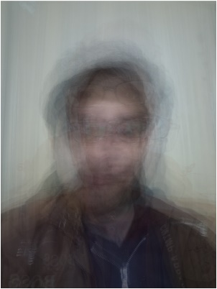

Fig. The mean Image

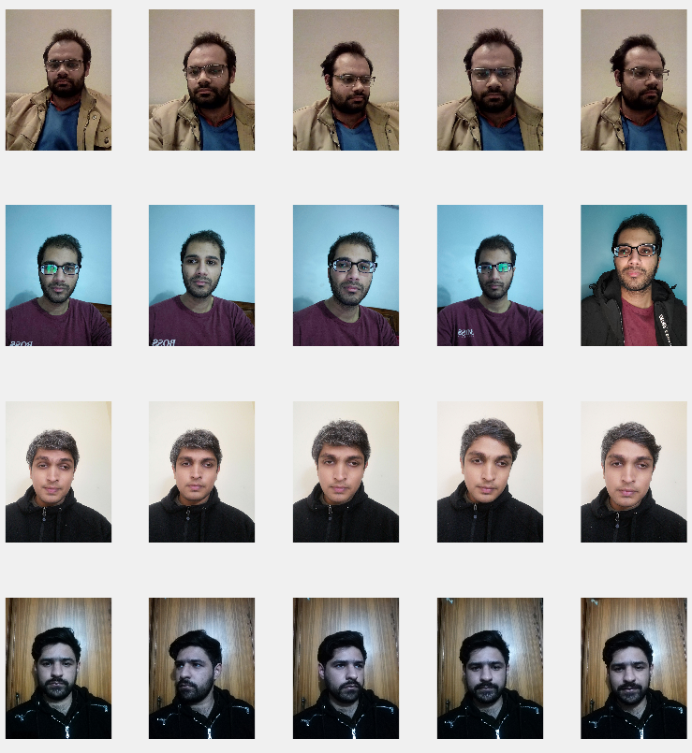

Fig. The original images

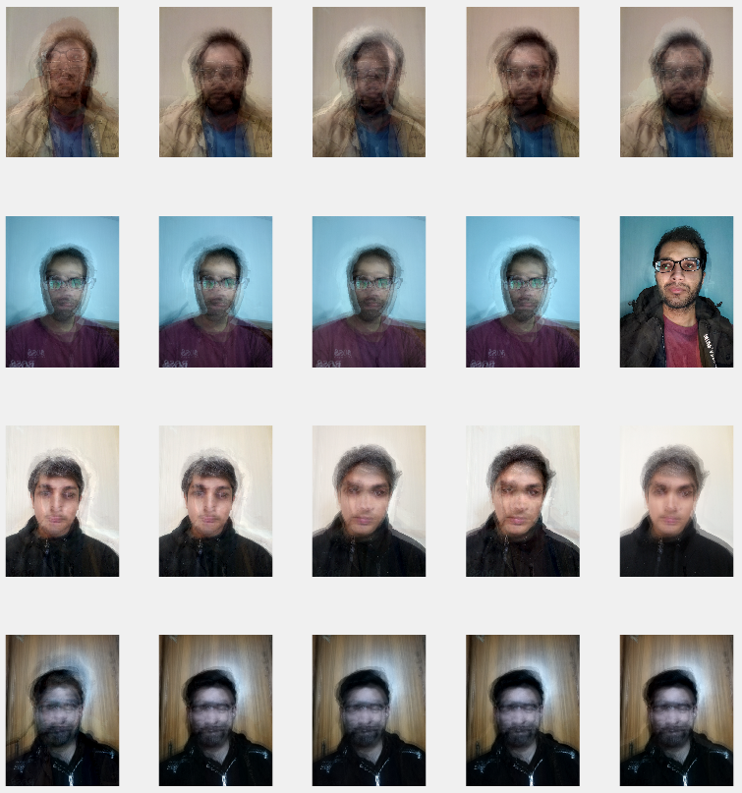

Fig. Images reconstructed with 5 principal components. The error was 8.5834exp(-14).

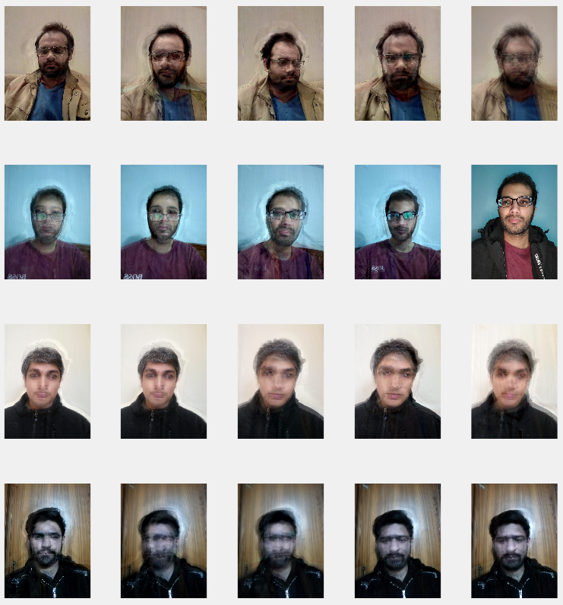

Fig. Images reconstructed with 10 principal components. The error was -4.2652exp(-14).

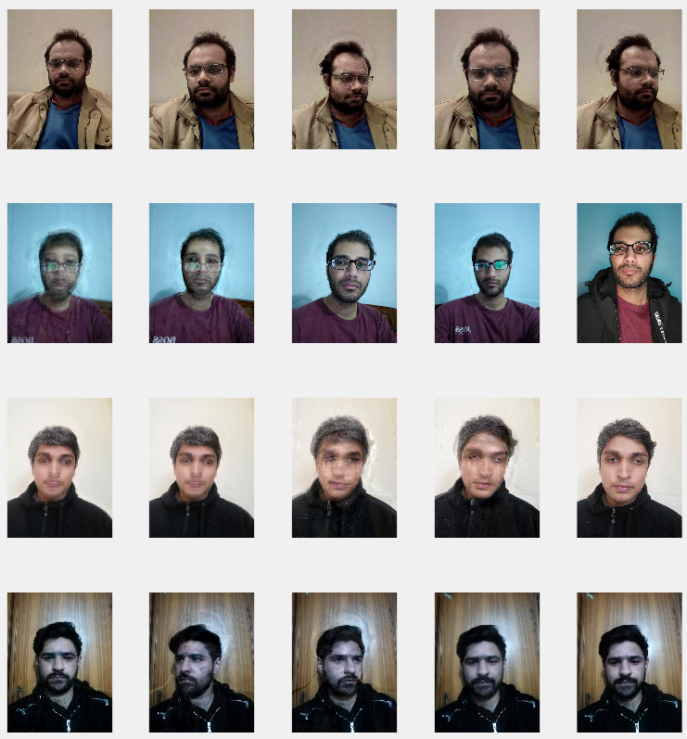

Fig. Images reconstructed with 15 principal components. The error was 1.5253exp(-14).

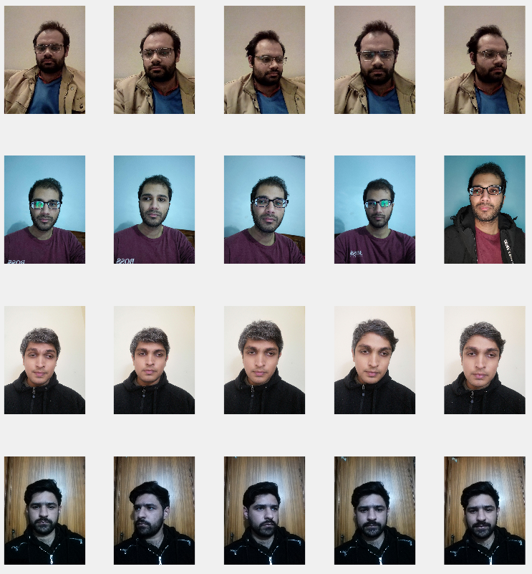

Fig. Images reconstructed with 20 principal components. The error was 1.4318exp(-15).

# Recognition

## Methodology

1. Projections of all images in the dataset are calculated as the dot product of the mean normalized and the reduced matrices.
2. A new image is loaded and converted to a column vector. The mean image is subtracted from it, and its projection with the reduced matrix is calculated.
3. Errors are calculated as the difference of projections of the images in the dataset, with the projection of the new image.
4. The image with the least error is displayed alongside the input image.

In the below images, the first image is the input image, and the second is the image in the dataset with the least error.

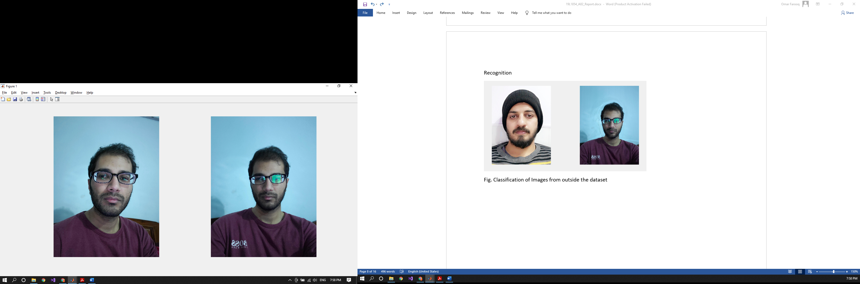

Fig. Image correctly classified

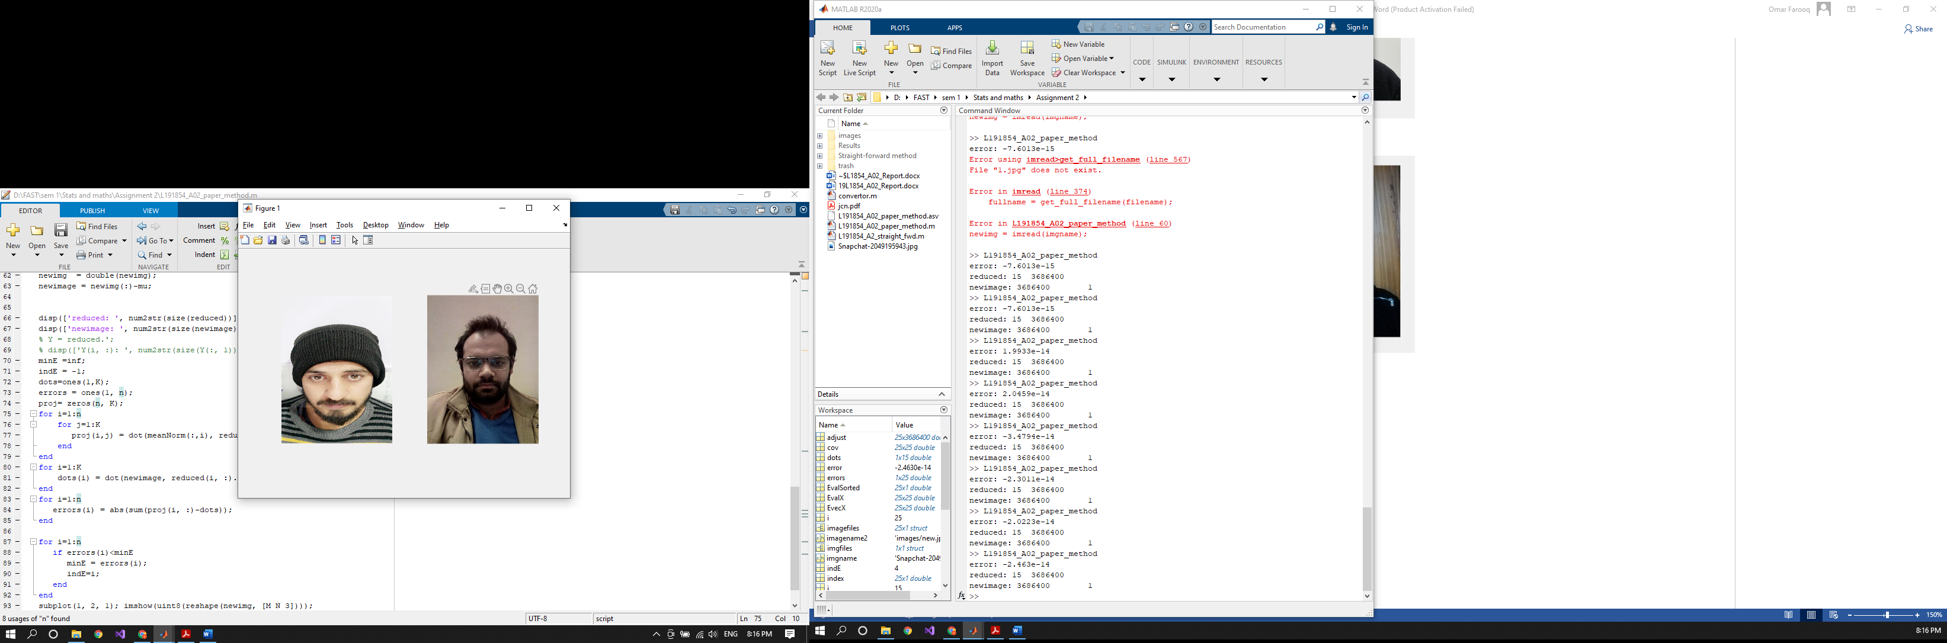

Fig. Image incorrectly classified. The mis-classification might have been a result of images in the set of the input images being from different angles.

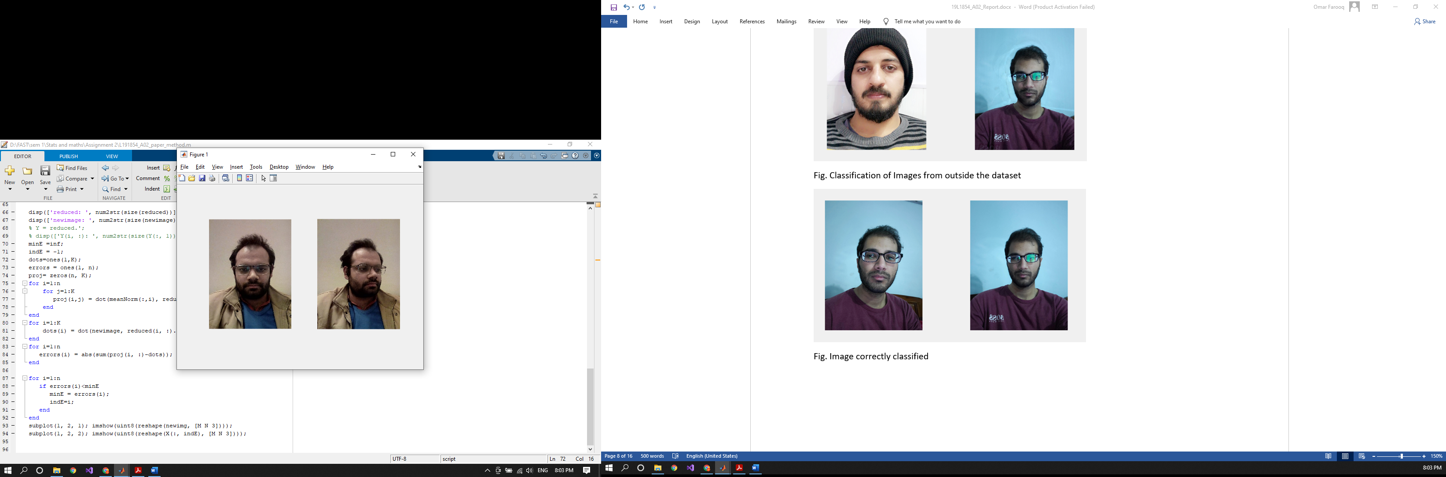

Fig. Image correctly classified

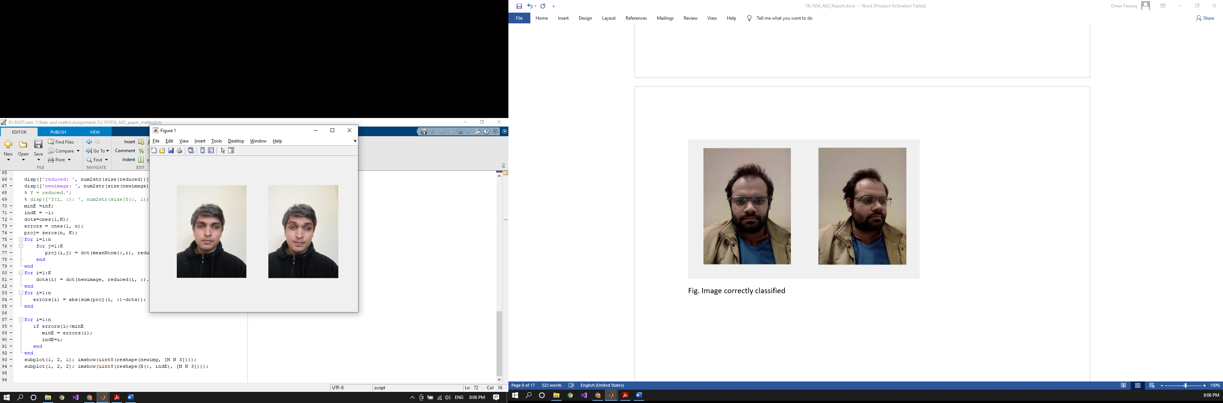

Fig. Image correctly classified

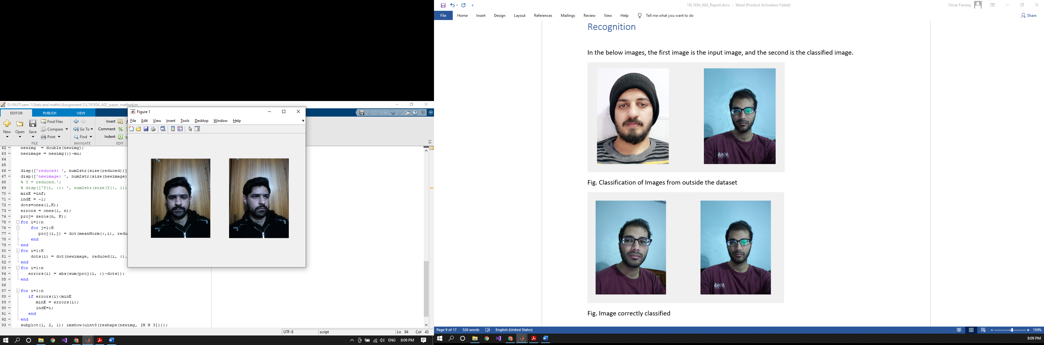

Fig. Image correctly classified

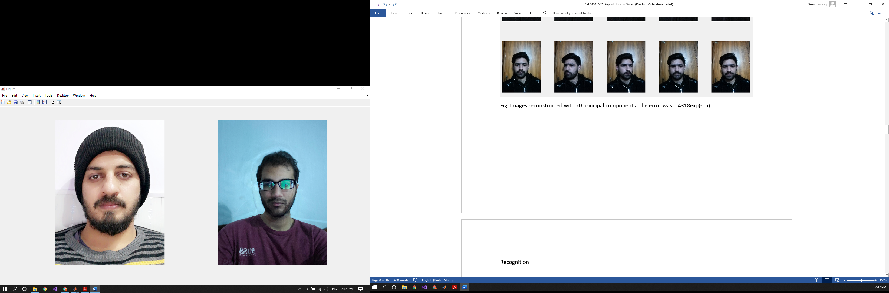

Fig. Classification of Images from outside the dataset

# Experiment 2

PCA was performed using the regular method on a size reduced form of the dataset for comparison. The images were compressed to 64x64 dimensions.

## Methodology

1. Images were resized and converted into a row-wise vector. Multiple images were added together in separate columns to give a matrix. This matrix was mean normalized.
2. Covariance matrix was given by multiplying the mean normalized matrix obtained to its transpose and dividing by the number of pixels.
3. Eigen values and eigenvectors were computed from the covariance matrix. The largest ‘k’ eigenvalues and vectors were chosen as the principal components.
4. The reduced form was calculated by multiplying the principal components with the mean normalized matrix.
5. The adjusted matrix was obtained by multiplying the transpose of the principal components with the reduced form. Mean was then added, and matrix transposed to give the reconstructed image.

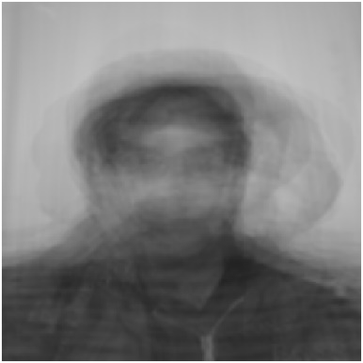

Fig. The mean image.

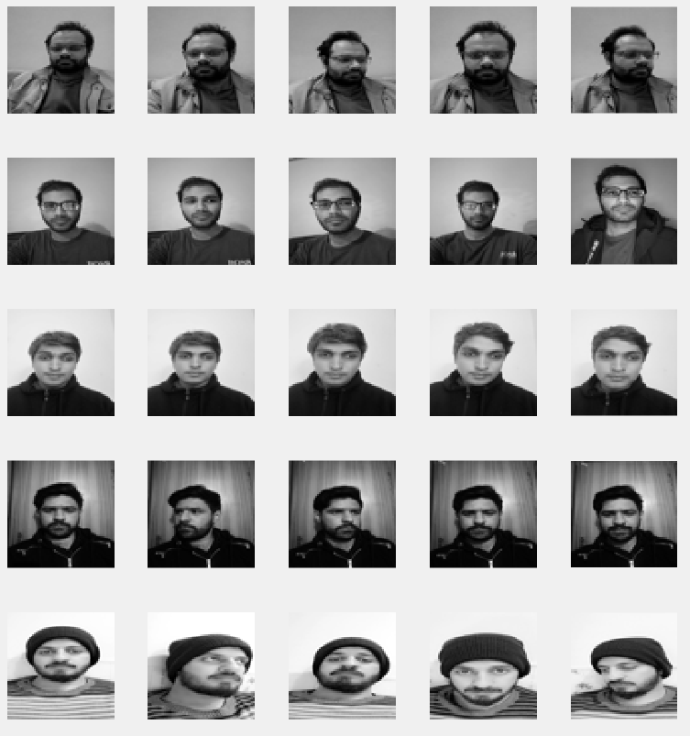

Fig. Images after they were converted to grayscale and resized. These were input to the model.

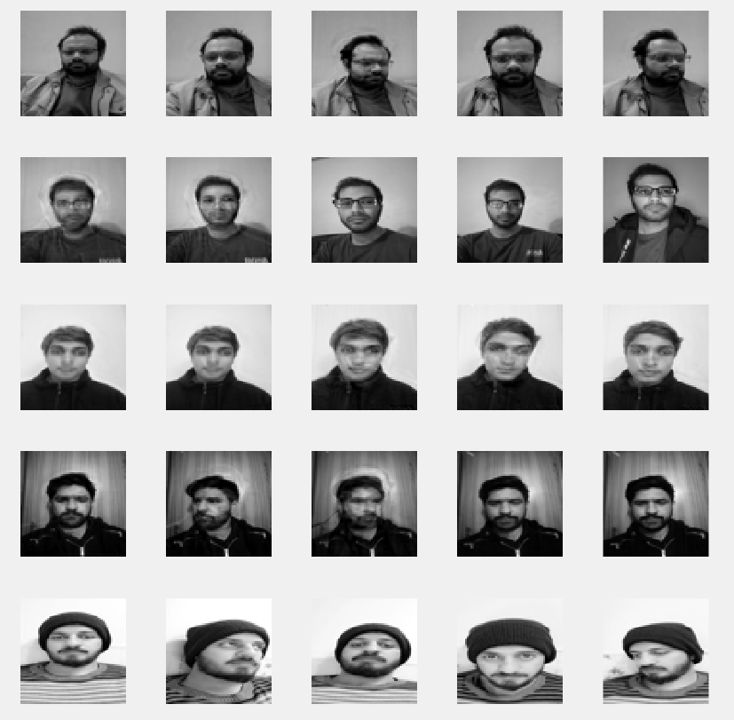

Fig. Images reproduced with top 20 eigenvectors. Error = 2.7534exp(-15).

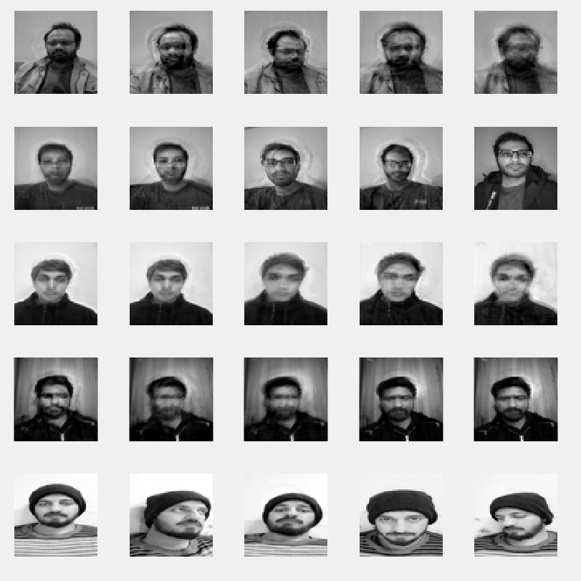

Fig. Images reproduced with top 15 eigenvectors

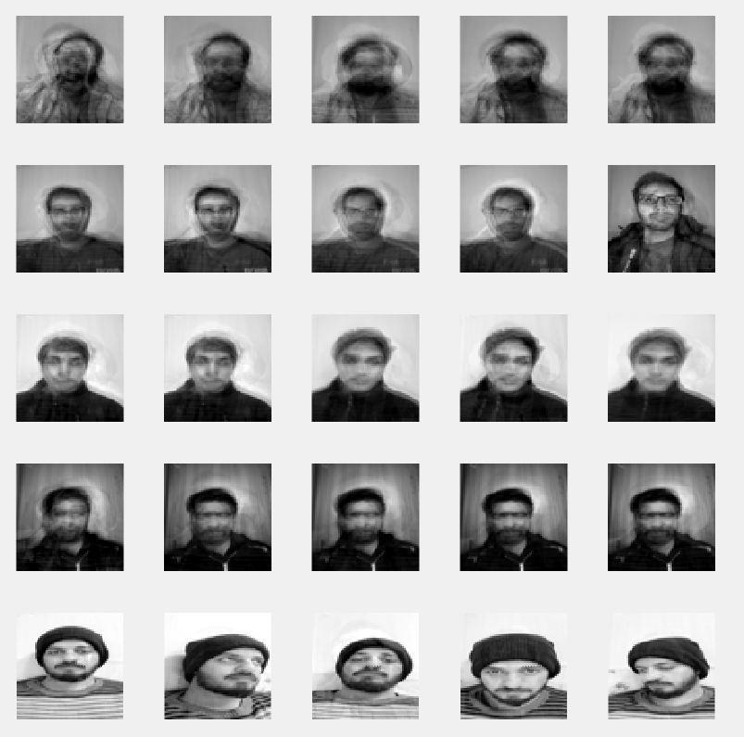

Fig. Images reproduced with top 10 eigenvectors

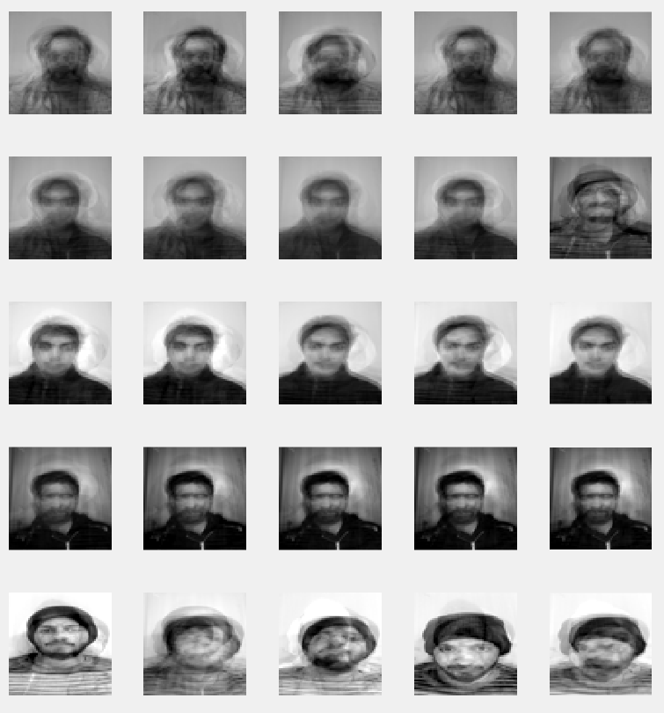

Fig. Images reproduced with top 5 eigenvectors

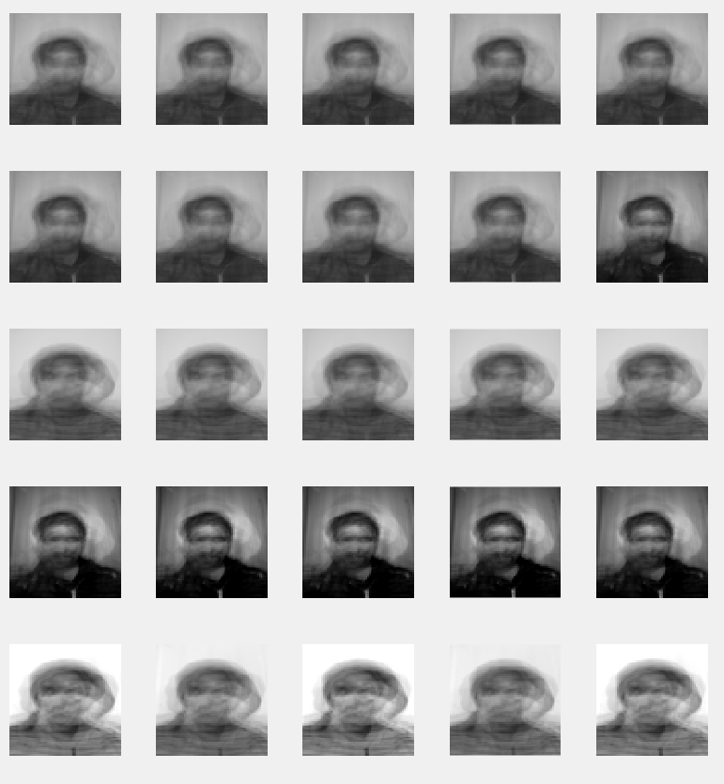

Fig. Images reproduced with top eigenvector. Error: 5.6621exp(-17)

# Conclusion

We see that the method of the paper allows for reconstruction and classification of multiband images of full resolution, in contrast to gray scale images of 64x64 dimensions as performed by the regular PCA method. In addition to this, the paper methodology also allowed for more complete reconstruction of images with top 20 eigenvectors. The time complexity of the two methods was similar.